


Partners in Practice

System Design
For
Mentoring Pairs for Child Care Design (Stage 2)
Version 1.0

July 30, 2026

Prepared by:  Michael Cullymore  Nicom IT Solutions Inc.  Suite 8, 6960 Mumford Road  Halifax NS  B3L 4P1  Phone: 902.454.5656  Fax: 902.484.3258  Web: www.nicomit.com | Version History:  May 05, 2008 – First Draft

Table of Contents

Data Flow Diagrams 3
Entity Relationship Diagrams 3
Introduction 3
Process 2.0 – Mentee Options 3
Process 2.1 – Mentee Occupational Standards Test 3
Process 3.0 – Mentor Options 3
Process 3.1 – Mentor Occupational Standards Test 3
Process 3.2 – Mentor Mentoring Attitudes and Predispositions 3
Process 4.0 – ECCDC Options 3
Database summary 3

Data Flow Diagrams
Partners in Practice – MPMT

Top Level Data Flow
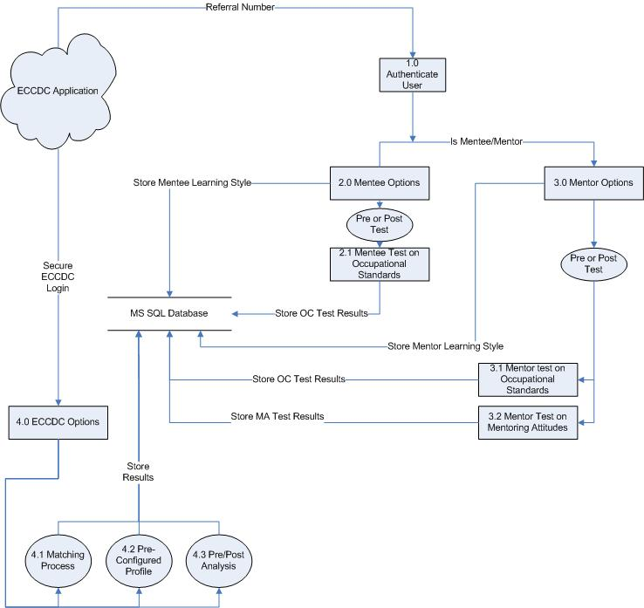

Entity Relationship Diagrams

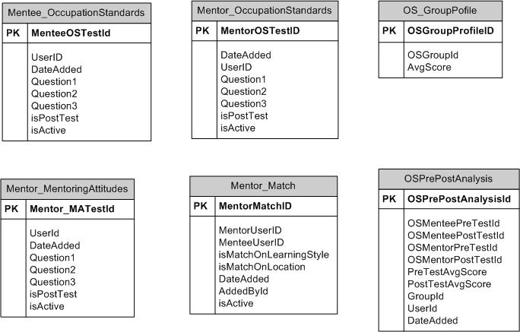

Introduction

This design specification was created to portray the concept of the Mentor Pair Matching system to be used at Early Childhood Community Development Centre. The Early Childhood Community Development Centre has requested a new mentoring pair matching tool (MPMT) to provide the means for its mentee’s to submit test credentials from a website using a reference number. Also allow ECCDC employee’s to enter mentors and all other pertinent information for use with the internal MPMT, allowing the ECCDC to retrieve matches and other statistical information.

The application is intended to provide improved functionality and ease-of-use to mentors, mentees and ECCDC, as well as keeping the applications administrative tasks as simple as possible.

Due to its basic similarity of function, the new MPMT is to streamline the functionality of the existing mentoring pair matching tool currently existing in access. This will be done in a new web based application.
The online application form will allow access to mentees and mentors with a referral number. Nicom IT will develop the second stage of the application in junction with the first stage being done by the ECCDC.
Process 1.0 – Authenticate User
Tables Used:
ECCDC Application Read

User Interface Design

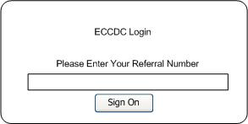

Process Description

The initial login screen appears when you first enter the ECCDC web site. The user must enter a valid referral number to get into the system. Clicking [Sign On] validates the referral number by retrieving the information from the ECCDC database and sets the type of access as mentee or mentor that this particular user has with the system. This will direct them to the process 2.0 for the mentee options or 3.0 for the mentor options.

If the referral number is incorrect or if the user’s account has been deactivated, the user will be notified allowing them to retry the sign in process.

Process 2.0 – Mentee Options

Tables Used:

User Interface Design

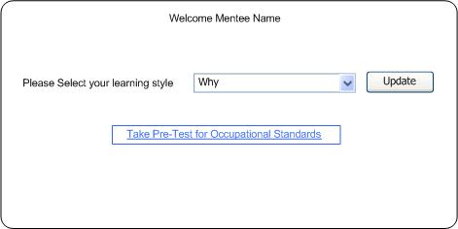

Process Description
This process will allow a mentee who has successfully logged in to first select their learning style. There will be four options from the drop down box Type 1 “Why”, Type 2 “What is there to know”, Type 3 “How”, Type 4 “what if”.

The second step for the mentee is to take the Occupational Standards test. The system will decide if this is a pre or post test if the mentee has already completed the pre test and gone thought the system. The link will be the same to the test questionnaire except the data will be stored as a separate record, one record for the pre test and one record for the post test.

Process 2.1 – Mentee Occupational Standards Test

Tables Used:
Mentee_OccupationStandards Write

User Interface Design

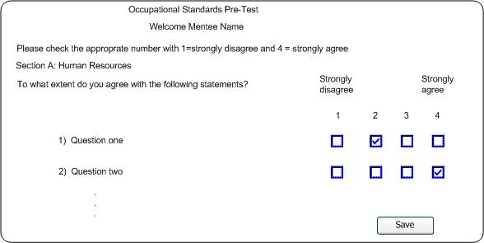

Process Description

The mentee will select to take the Occupational Standards test from process 2.0. This screen will allow the mentee to answer all the questions by checking the appropriate check boxes.

The answers will be stored in the database and flagged as a pre or post test.

Process 3.0 – Mentor Options

Tables Used:

User Interface Design

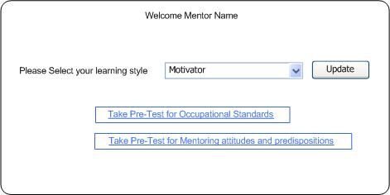

Process Description

This process will allow a mentor who has successfully logged in to first select and update their learning style. There will be four options from the drop down box Type 1 “motivator”, Type 2 “expert”, Type 3 “coach”, Type 4 “enabler”.

The second step for the mentor is to take the Occupational Standards test. The system will decide if this is a pre or post test if the mentee has already completed the pre test and gone thought the system. The link will be the same to the test questionnaire except the data will be stored as a separate record, one record for the pre test and one record for the post test.

The third step for the mentor is to take the Mentoring Attitudes and Predispositions test. The system will decide if this is a pre or post test if the mentee has already completed the pre test and gone thought the system. The link will be the same to the test questionnaire except the data will be stored as a separate record, one record for the pre test and one record for the post test.

Process 3.1 – Mentor Occupational Standards Test

Tables Used:
Mentor_OccupationStandards Write

User Interface Design

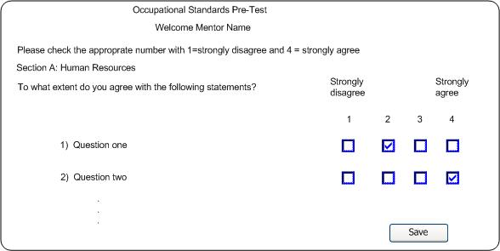

Process Description

The mentor has selected to take the Occupational Standards test from process 3.0. This screen will allow the mentor to answer all the questions by checking the appropriate check boxes.

The answers will be stored in the database and flagged as a pre or post test.

Process 3.2 – Mentor Mentoring Attitudes and Predispositions

Tables Used:
Mentor_MentoringAttitudes Write

User Interface Design

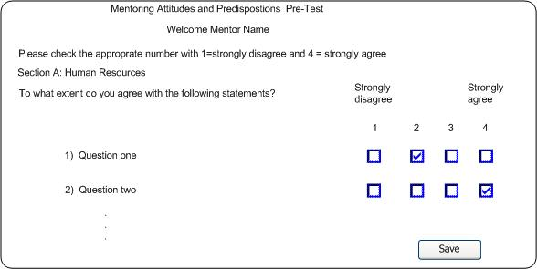

Process Description

The mentor has selected to take the Mentoring Attitudes and Predispositions test from process 3.0. This screen will allow the mentor to answer all the questions by checking the appropriate check boxes.

The answers will be stored in the database and flagged as a pre or post test.

Process 4.0 – ECCDC Options

Tables Used:
Mentor_Match Write
OS_GroupPofile Write
PrePostAnalysis Write
MAPrePostAnalysis Write
User Interface Design

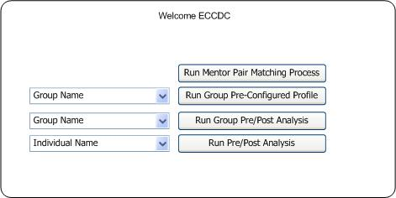

Process Description

This process contains all of the sub-processes related to ECCDC analysis such as running the Mentor Pair Matching process.

The mentor pair matching process will execute against the ECCDC database and match Mentor with mentees based on their pre defined community. The results will be prioritized by proximity first then learning style.
Note: The proximity will be based on postal code, which the ECCDC will supply the formula.

The mentor and mentee will have chosen one of four learning styles. A type “A” Mentor will be matched with a type 1 Mentee, type B with a type 2, type C with a type 3, type D with type 4. The results will be stored in the table Mentor_Match.

The Profile process will gather the averages of the selected groups average scores on the Occupational Standards self assessments. The result set will be stored in the table OS_GroupPofile.

The Pre/Post Analysis process generate dataset of the occupational standards and mentors attitudes and predispositions self assessment test for comparison with their post test scores on an individual or group basis. The results will be stored in OCPrePostAnalysis and MAPrePostAnalysis tables.

Database summary
Number of tables: 6
Number of views: 0
Number of columns: 45
Number of indexes: 0
Number of foreign keys: 0

Tables | Columns | Indexes | Foreign keys | Notes
OSPrePostAnalysis | 10 | 0 | 0
OS_GroupPofile | 3 | 0 | 0
Mentor_Match | 8 | 0 | 0
Mentor_MentoringAttitudes | 8 | 0 | 0
Mentor_OccupationStandards | 8 | 0 | 0
Mentee_OccupationStandards | 8 | 0 | 0

Mentee_OccupationStandards

Number of columns: 8
Number of indexes: 0
Number of foreign keys: 0
Codes: 0
Type: Table

Columns | Data type | Allow NULLs | Value/Range
MenteeOSTestId | INTEGER | Not allowed
UserID | INTEGER | Allowed
DateAdded | DATETIME | Not allowed
Question1 | INTEGER | Not allowed
Question2 | INTEGER | Not allowed
Question3 | INTEGER | Not allowed
isPostTest | BIT | Not allowed
isActive | BIT | Not allowed

Column details
1. MenteeOSTestId
Physical data type: INTEGER
Allow NULLs: Not allowed

2. UserID
Physical data type: INTEGER
Allow NULLs: Allowed
Notes: UserID is the user id retreived with the referal number

3. DateAdded
Physical data type: DATETIME
Allow NULLs: Not allowed
Notes: dateAdded is date the user saved the test

4. Question1
Physical data type: INTEGER
Allow NULLs: Not allowed
Notes: Question1 is one of up to 30 questions for this test d is stored on a rate of 1-4

5. Question2
Physical data type: INTEGER
Allow NULLs: Not allowed
Notes: Question2

6. Question3
Physical data type: INTEGER
Allow NULLs: Not allowed
Notes: Question3

7. isPostTest
Physical data type: BIT
Allow NULLs: Not allowed
Notes: isPostTest is this a Pre Test or Post Test Default False

8. isActive
Physical data type: BIT
Allow NULLs: Not allowed
Notes: isActive in case done more than once Default True

Mentor_Match

Owner:
Target DB name:
Number of columns: 8
Number of indexes: 0
Number of foreign keys: 0
Codes: 0
Type: Table

Columns | Data type | Allow NULLs | Value/Range
MentorMatchID | INTEGER | Not allowed
MentorUserID | INTEGER | Not allowed
MenteeUserID | INTEGER | Not allowed
isMatchOnLearningStyle | BIT | Not allowed
isMatchOnLocation | BIT | Not allowed
DateAdded | DATETIME | Not allowed
AddedById | INTEGER | Not allowed
isActive | BIT | Not allowed

Column details
1. MentorMatchID
Physical data type: INTEGER
Allow NULLs: Not allowed

2. MentorUserID
Physical data type: INTEGER
Allow NULLs: Not allowed
Notes: MentorUserID is retreived from ECCDC Database

3. MenteeUserID
Physical data type: INTEGER
Allow NULLs: Not allowed
Notes: MenteeUserID is retreived from ECCDC Database

4. isMatchOnLearningStyle
Physical data type: BIT
Allow NULLs: Not allowed
Notes: isMatchOnLearningStyle was the match done on learning style

5. isMatchOnLocation
Physical data type: BIT
Allow NULLs: Not allowed
Notes: isMatchOnLocation was the match done on location

6. DateAdded
Physical data type: DATETIME
Allow NULLs: Not allowed
Notes: DateAdded is the date the match was added to table

7. AddedById
Physical data type: INTEGER
Allow NULLs: Not allowed
Notes: AddedById is the User Id of the person who ran the process

8. isActive
Physical data type: BIT
Allow NULLs: Not allowed

Mentor_MentoringAttitudes

Number of columns: 8
Number of indexes: 0
Number of foreign keys: 0
Codes: 0
Type: Table

Columns | Data type | Allow NULLs | Value/Range
Mentor_MATestId | INTEGER | Not allowed
UserId | INTEGER | Not allowed
DateAdded | DATETIME | Not allowed
Question1 | INTEGER | Not allowed
Question2 | INTEGER | Not allowed
Question3 | INTEGER | Not allowed
isPostTest | BIT | Not allowed
isActive | BIT | Not allowed

Column details
1. Mentor_MATestId
Physical data type: INTEGER
Allow NULLs: Not allowed

2. UserId
Physical data type: INTEGER
Allow NULLs: Not allowed
Notes: UserId is of retrieved with Referal number on login

3. DateAdded
Physical data type: DATETIME
Allow NULLs: Not allowed
Notes: DateAdded is date user saved test

4. Question1
Physical data type: INTEGER
Allow NULLs: Not allowed
Notes: Question1 is one of 30 questions values are 1-4

5. Question2
Physical data type: INTEGER
Allow NULLs: Not allowed
Notes: Question2

6. Question3
Physical data type: INTEGER
Allow NULLs: Not allowed
Notes: Question3

7. isPostTest
Physical data type: BIT
Allow NULLs: Not allowed
Notes: isPostTest is this a pre test or post test

8. isActive
Physical data type: BIT
Allow NULLs: Not allowed
Notes: isActive in case done more than once Default True

Mentor_OccupationStandards

Number of columns: 8
Number of indexes: 0
Number of foreign keys: 0
Codes: 0
Type: Table

Columns | Data type | Allow NULLs | Value/Range
MentorOSTestID | INTEGER | Not allowed
DateAdded | DATETIME | Not allowed
UserID | INTEGER | Not allowed
Question1 | INTEGER | Not allowed
Question2 | INTEGER | Not allowed
Question3 | INTEGER | Not allowed
isPostTest | BIT | Not allowed
isActive | BIT | Not allowed

Column details
1. MentorOSTestID
Physical data type: INTEGER
Allow NULLs: Not allowed

2. DateAdded
Physical data type: DATETIME
Allow NULLs: Not allowed
Notes: dateAdded is the date the user saved the test

3. UserID
Physical data type: INTEGER
Allow NULLs: Not allowed
Notes: UserID is of retreived with the referal number

4. Question1
Physical data type: INTEGER
Allow NULLs: Not allowed
Notes: Question1 is one of 30 questions and is stored on a rate of 1-4

5. Question2
Physical data type: INTEGER
Allow NULLs: Not allowed
Notes: Question2

6. Question3
Physical data type: INTEGER
Allow NULLs: Not allowed
Notes: Question3

7. isPostTest
Physical data type: BIT
Allow NULLs: Not allowed
Notes: isPostTest is this a Pre Test or Post test

8. isActive
Physical data type: BIT
Allow NULLs: Not allowed
Notes: isActive in case done more than once Default True

OS_GroupPofile

Number of columns: 3
Number of indexes: 0
Number of foreign keys: 0
Codes: 0
Type: Table

Columns | Data type | Allow NULLs | Value/Range
OSGroupProfileID | INTEGER | Not allowed
OSGroupId | INTEGER | Not allowed
AvgScore | INTEGER | Not allowed

Column details
1. OSGroupProfileID
Physical data type: INTEGER
Allow NULLs: Not allowed

2. OSGroupId
Physical data type: INTEGER
Allow NULLs: Not allowed
Notes: OSGroupId is Group Selected for Profile

3. AvgScore
Physical data type: INTEGER
Allow NULLs: Not allowed
Notes: AvgScore is the average scored of the Group values 1-4

OSPrePostAnalysis

Number of columns: 10
Number of indexes: 0
Number of foreign keys: 0
Codes: 0
Type: Table

Columns | Data type | Allow NULLs | Value/Range
OSPrePostAnalysisId | INTEGER | Not allowed
OSMenteePreTestId | INTEGER | Allowed
OSMenteePostTestId | INTEGER | Allowed
OSMentorPreTestId | INTEGER | Allowed
OSMentorPostTestId | INTEGER | Allowed
PreTestAvgScore | INTEGER | Allowed
PostTestAvgScore | INTEGER | Allowed
GroupId | INTEGER | Allowed
UserId | INTEGER | Not allowed
DateAdded | DATETIME | Not allowed

Column details
1. OSPrePostAnalysisId
Physical data type: INTEGER
Allow NULLs: Not allowed

2. OSMenteePreTestId
Physical data type: INTEGER
Allow NULLs: Allowed
Notes: OSMenteePreTestId Only one or the other Mentee or Mentor populated

3. OSMenteePostTestId
Physical data type: INTEGER
Allow NULLs: Allowed
Notes: OSMenteePostTestId Only one or the other Mentee or Mentor populated

4. OSMentorPreTestId
Physical data type: INTEGER
Allow NULLs: Allowed
Notes: OSMentorPreTestId Only one or the other Mentee or Mentor populated

5. OSMentorPostTestId
Physical data type: INTEGER
Allow NULLs: Allowed
Notes: OSMentorPostTestId Only one or the other Mentee or Mentor populated

6. PreTestAvgScore
Physical data type: INTEGER
Allow NULLs: Allowed

7. PostTestAvgScore
Physical data type: INTEGER
Allow NULLs: Allowed

8. GroupId
Physical data type: INTEGER
Allow NULLs: Allowed

9. UserId
Physical data type: INTEGER
Allow NULLs: Not allowed
Notes: UserId is of user who took the test

10. DateAdded
Physical data type: DATETIME
Allow NULLs: Not allowed

